Registry

* Images are stored in registry
* Repository inside a registry is collection of one or more images
* Each image in a repository is stored as tag
* Typically tag refers to version of image but it can also refer to different variation of image. We can add tag to any value to differentiate image from others.

Most of the public images we pull from docker.io registry

docker pull docker.io/ubuntu:bionic

In above command docker.io is registry, ubuntu is repository and bionic is tag

If we don’t provide registry name then docker automatically takes it as docker.io

docker pull ubuntu:bionic

if we have another private or other vendor registry then we can provide that name else default will be docker.io

sometimes instead of docker.io we can see ‘registry.hub.docker.com’ as registry. It is just a different DNS name but older one for docker.io.

** if you see image is getting pulled from library/ubuntu where **library** is namespace and usually while pulling images from repo, namespace is also used.

Ex. docker pull <<namespace>>/<<repository>>:<<tag>>

Ex. pulling image from docker.io registry

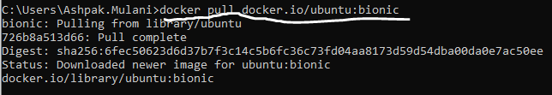

Pulling same image from registry.hub.docker.com

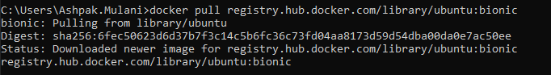

As you see below even if both the images are same ref. ImageID but when we have to refer them in docker commands, we need to use REPOSITORY : TAG means both the images are referred using different names.

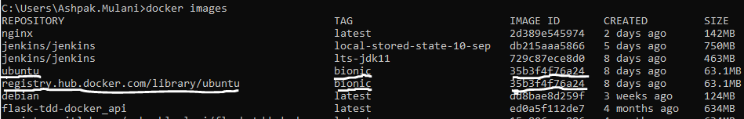

If we have personal repository on docker.io then image name will look like this docker.io/<<username>>/<<repository>>:<<tag>>